Discord Set Up Guide
- Use Template
  - https://discord.new/8BGa8AJbaCHR
  - 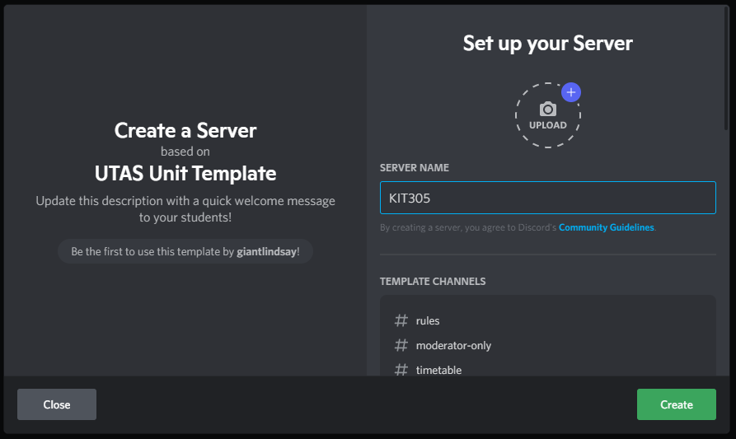
  - Use this opportunity to set a server icon

  - Provided channels:
    - 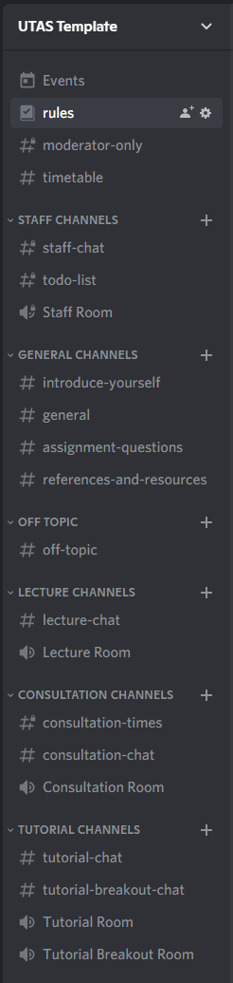
  - Provided roles:
    - Unit Coordinator
      - Administrator
    - Tutor
      - Moderation privileges
    - Everyone
      - Basic permissions
- Add Robo Lindsay
- Familiarise yourself with Server Settings
  - 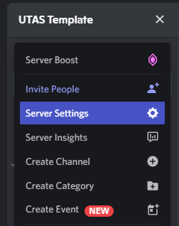
- Set as Community server
  - 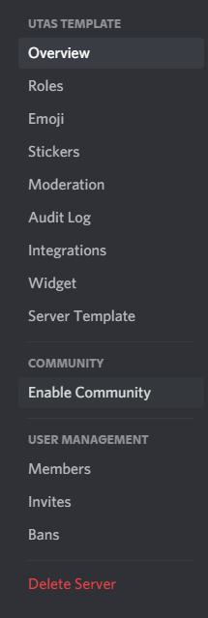
  - 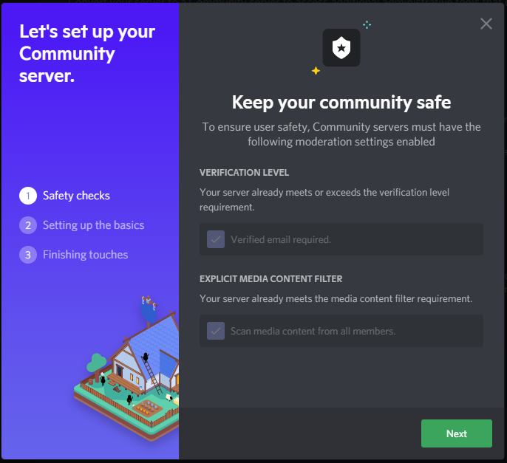
  - Verified Email yes
  - Explicit Content Filter yes
  - 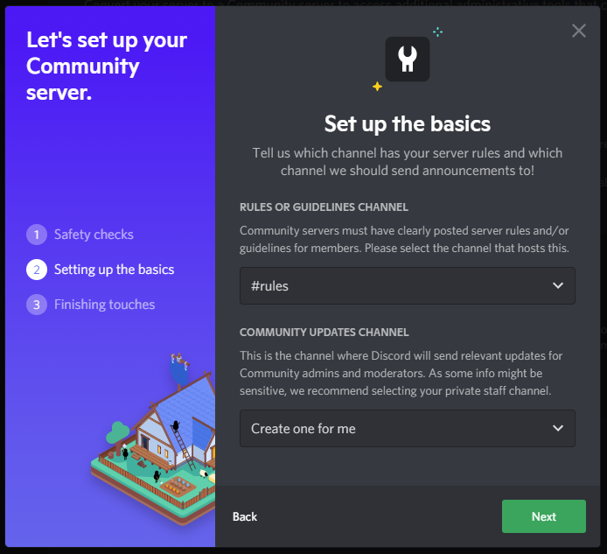
  - Select Rules channel
  - Community Updates ignore
  - 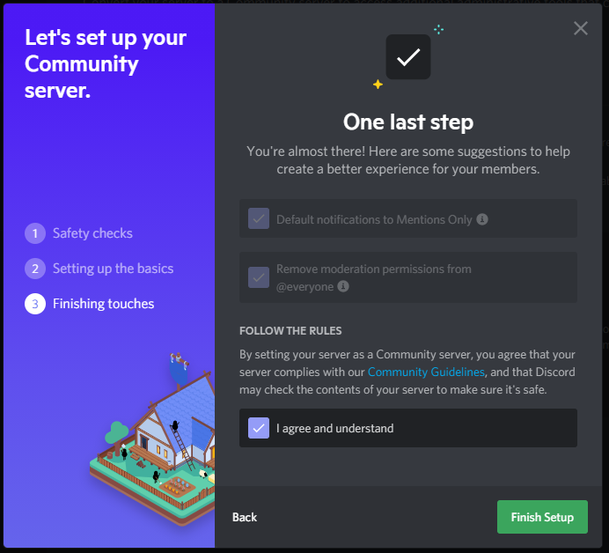
  - Default notifications Mention Only Yes
  - Remove moderation yes
  - Agree
- Set Up Membership screening
  - 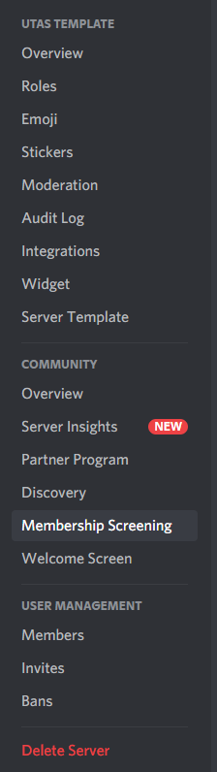
  - Server Rules
    - Template
- Set Up Welcome Screen
  - 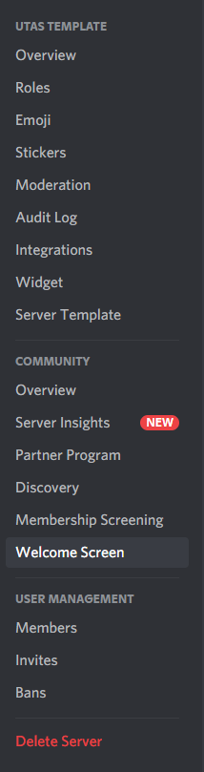
  - Recommended Channels
    - Rules
    - Introductions channel
    - Lecture channel
    - Assignment help channel
    - Consultation channel
- Generate an invite link
  - Robo Lindsay
    - With auto-assigned role
  - Or generate your own
    - Be in the channel you want people to arrive at when you generate this link
    - 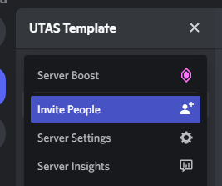
    - 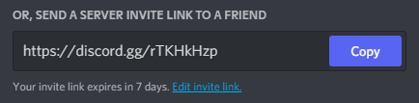
    - Set to not expire
    - 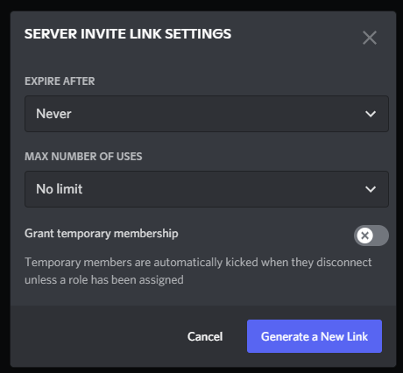
    - Copy the link

- Consider posting this handy guide on MyLO
  - TODO
- Consider a role select for campus / tutorial selection etc
- Remove lecture/consultation/tutorial as needed
- Consider achievements

UTAS Discord Bot (aka Robo-Lindsay)
